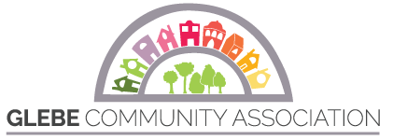
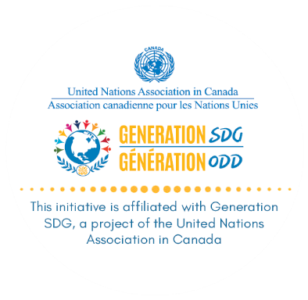

Idle-Free Schools in the Glebe:
Poster Design Competition for Grades 3 to 6

For more information, visit glebeca.ca
A competition to support reduced idling in school zones and healthier air for students and the education community

Sponsored by the Glebe Community Association, in cooperation with the United Nations Association in Canada’s SDG Ambassador, in support of three Sustainable Development Goals: 3) Good Health and Well-Being, 11) Sustainable Cities and Communities 13) Climate Action.

Introduction
Good Health and Well-Being: Supporting the well-being of schools means helping to keep kids healthy, and their families, guardians and educators too. This depends on many factors, among which air quality is critical. The link between air pollution and respiratory conditions such as asthma is clear, and children are among the most vulnerable. Health Canada estimates that air pollution contributes to 15,300 premature deaths per year in Canada.
While air pollution arises from many sources, transportation is one of the top contributors. And there is one simple way for individuals to help reduce pollution: by turning off their motor vehicles when they are not in motion. That is, by not idling.
This competition aims to encourage drivers around school zones to cut their engines while waiting for children or anytime they are parked and not going anywhere.

Sustainability and Climate Action: Schools are climate action leaders in the broader community. Their teachers and administrators recognize the importance of educating on issues of climate change, beginning with the individual’s climate footprint and expanding to the city, country and international levels. Children and parents are engaged in these issues and keen to make a personal and collective contribution.
By reducing idling, individuals can play a role in reducing community carbon emissions and thereby support climate action.

A Poster Design Competition for Children at Glebe Schools
We invite participation from students in grades 3 to 6 at all Glebe elementary schools.
We invite parents, school councils, teachers and principals to promote the competition in their schools and encourage students to join in.
Please share information about the contest in your newsletters and with friends who have children in Glebe primary schools.
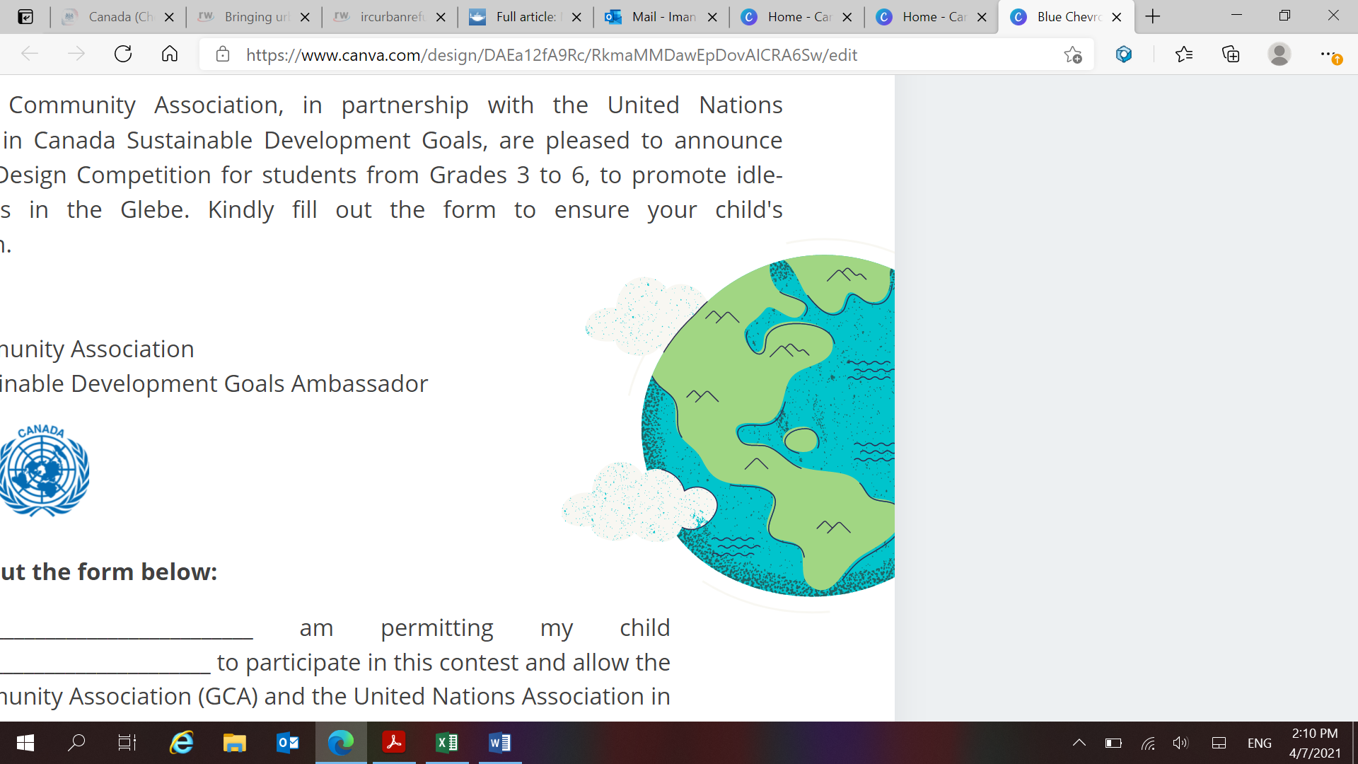

Our Goal and Suggested Themes
We encourage posters that convey messages such as:
- Our School Is Idle-Free
- Idle-Free School Zone: Kids at Work!
- Breathing in progress: Stop your engine when you’re not moving
- Stop a block away, park and walk: Make our school safe!
- Kids Zone: No idling please
- Turn off your engine: keep our air clean
- Not moving? Turn it off.

Prizes and Recognitions
A winner at each school will have their poster featured in community newspapers/newsletters and social media. Posters may also be reproduced as banners to be posted around schoolyards.
Each school winner will receive a certificate and a $50 prize. Grade level winners at each school will receive certificates. If possible, the Glebe Community Association will arrange a ceremony for the awarding of prizes and certificates at each school.
Competition Rules
- Posters will be primarily visual. Text used may be in English and/or French.
Ideas/models at:
https://oee.nrcan.gc.ca/transportation/idling/material/campaign-resources.cfm?attr=28#posters
http://dadacanada.com/downloads/
https://iturnitoff.com/resources.html
https://www.epa.gov/schools/idle-free-schools-toolkit-healthy-school-environment

- Any medium is acceptable for the design competition. This includes:
- Plain paper, poster board or construction paper
- Pencil, crayons, colouring pencils, markers, paint, chalk
- Collage using construction paper, magazine cut-outs, etc.
- Digital photography, designs, other free or purchased online graphics and photos

Posters may be of any size and shape, but it is useful to think in terms of signage (e.g., lawn signs, election signs and banners).
- All students from grades 3 to 6 are welcome to participate.
- The student’s first name only, and grade, should be on the front of the work.
- Glebe Community Association (GCA) and the United Nations Association in Canada (UNAC) may post online, reproduce or otherwise use the winning artwork in order to promote the idle-free message.
- Submissions will be accepted in the following electronic formats: scan or photo of artwork sent as an attachment to environment@glebeca.ca.
- Winners will be required to provide the original artwork for use by GCA/UNAC.
- Include an email address for notification purposes (parent, teacher or principal).
- The panel of judges will be from the GCA. Judges’ decisions are final.
- At each school, GCA will select an overall winning submission and a winner for each grade level.
- Winning submissions will be judged based on the following criteria:
- Creativity and originality
- Clarity of message
- Impact of message

- The deadline for submissions to GCA is May 14, 2021.
- Notification will be sent to winners by May 28, 2021, at the email address provided with the submission.
- Winning students/parents must then email the student’s full name, grade, school, email address and phone number to: environment@glebeca.ca.
- Winning students/parents will be asked to confirm permission to the Glebe Community Association (GCA) and the United Nations Association in Canada (UNAC) to post online, reproduce or otherwise use the winning artwork to promote the idle-free message.
- GCA/UNAC reserve the right to verify the ownership of the artwork with the student’s parent/guardian or principal/teacher.
- Winners will be announced in community social media, the Glebe Report and other media in early June.

Visit: glebeca.ca
Questions? environment@glebeca.ca

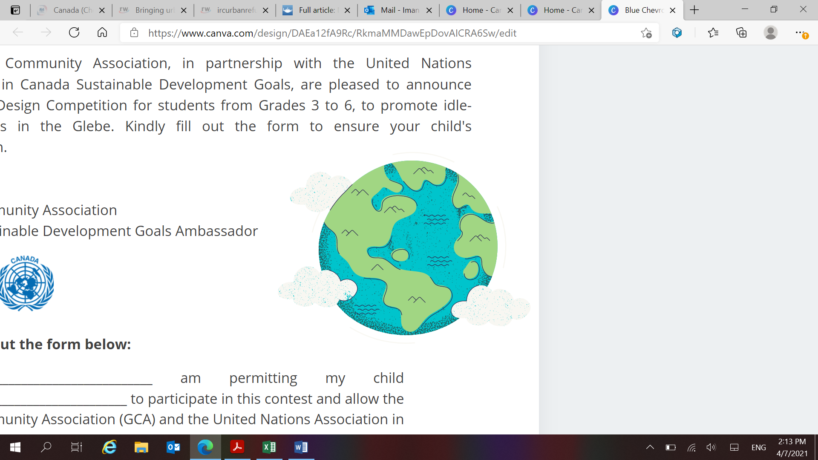
Good Luck!

