
GCA Board of Directors
Tuesday June 23, 2026 – Glebe Community Centre
DRAFT Minutes

Chair: John Crump, GCA President
Secretary and Timekeeper: Janet Sutherland

Participating Board members: Bob Brocklebank, June Creelman, John Crump, Rochelle Handelman, David Kelly, Deborah Long, Carol MacLeod, Angus McCabe, Genevieve McInnes, Jenny Pepall, Brenda Perras, Sheila Petzold, Janet Sutherland, Della Wilkinson, Judy Wilson, Catherine Waters, Meghan Watkinson, David Wright.
Regrets: Elizabeth Ballard, Martha Bowers, Maggie Gorman Velez, Vaughn Guy, Ryan Hampel, Carolyn Mackenzie, Edward Ocampo-Gooding, Johanna Persohn, Laura Smith, Sam Woods.
Representative from office of Councillor Menard: Hannah Tellier
Members of the community: Barbara Bienefeld, Manfred Bienefeld, Debbie DesRosiers, Farah Gulzar, Bill Price, Yashaswi Thapa.
1. Welcome and Call to Order – GCA President John Crump called the meeting to order, welcomed all attendees and acknowledged that the meeting was taking place on the unceded territory of the Algonquin-Anishinaabe peoples. A quorum of Board members was established (12).
2. Consent Agenda – The agenda was approved by consensus as presented. The minutes of May 26, 2026 were not ready for circulation, therefore approval was deferred. As part of the consent agenda, renewal of the GCA’s Zoom account was approved for $230.00.
3. City Councillor Report / Update from Shawn Menard’s Office
The Councillor’s representative Hannah Tellier provided updates on developments in the ward. Her full report is appended to the minutes.
Hannah noted the issues raised in the question period for future follow up and was thanked for her comprehensive report and participation in the meeting.
4. Committee Reports and Motions
Membership – Catherine Waters reported that the membership campaign was winding up and she was collecting the data from Area Reps in order to prepare a final list that could be used to issue invitations to the AGM. She noted she had been gathering suggestions for the future from Area Reps.
Environment – Della Wilkinson referred the Board to her submitted report which highlighted the Tiney Forest program at First Avenue public school. She reported on the approval of a $10K grant application that was approved by the City’s Community Environmental Project Grant Program (CEPGP) to support waste reduction in food services businesses in the Glebe (eg. Reducing single use plastics and adoption of reusable food and drinkware). The project is a collaboration with the BIA for implementation in September 2026. Della also noted the need for volunteers to support the various programs of the Environment Committee (eg. Garden Angels, Weed Warriors, and Tiny Forest).
Health, Housing and Social Services – Deborah Long presented the following motion on air conditioning noise from The Clemow (275 Carling Avenue):
WHEREAS The GCA passed a motion on 28 October 2025 requesting steps be taken to
resolve the issue of ongoing noise from rooftop air-conditioning equipment at The Clemow, a
16-storey residential development at 275 Carling Avenue;
WHEREAS the noise problem is continuing for a second year disturbing the peace and
tranquility of neighbourhood residents;
WHEREAS the noise from this stationary source is governed by Ontario&#39;s environmental noise standards -- NPC-300 and the tonal adjustment it carries from NPC-104 -- applied through City Planning, and not by the City&#39;s Noise By-law;
WHEREAS the steps taken by the building owners (KTS Properties / Katasa) to date have not
resolved the noise problems;
WHEREAS the City of Ottawa has required the owner to complete a Final Stationary Noise
Assessment and engineer&#39;s certification before the noise obligation under the Site Plan Control approval can be discharged, and that assessment remains outstanding;
BE IT RESOLVED THAT the Glebe Community Association requests that the City of Ottawa
require the Final Stationary Noise Assessment for The Clemow to:
1. be completed in accordance with NPC-300 and NPC-104, including the tonal
adjustment, as applicable, and assessed under the predictable worst-case (warm-
weather) operating conditions;
2. be made available to the affected community and its acoustic engineer for review before
the City treats the noise obligation as discharged; and
3. where the noise still exceeds the standards, be accompanied by additional remediation
measures sufficient to achieve compliance, with the securities held on the file retained
until compliance is independently verified;
AND BE IT FURTHER RESOLVED THAT this resolution be conveyed to City Planning, the
Ward Councillor, Member of Provincial Parliament, Ministry of Environment, Conservation & Parks, and the affected residents.
Moved/seconded (Sam Woods/June Creelman). CARRIED.

Nominations Committee – June Creelman reported on the state of nominations and renewals by current Board members. Recruitment is underway for a chair of Transportation and Membership committees as well as 3 Area Reps for Patterson Creek North and South and Powell/Clemow. The article in the Glebe Report has generated some interest and the committee is setting up meetings with potential candidates.
4. Year-end Financial Report – Treasurer David Kelly presented a financial report for the fiscal year 2025-26 (May 1, 2025-April 30, 2026). Membership revenue is the GCA’s only source of income and came in around $12,000. Total expenses were favourable to budget and a modest surplus was realized. At year-end, the GCA had $35, 479.30 in the bank. Ted Lupinsky will review the finances again this year and prepare a report for the AGM in September.
Moved/seconded (David Kelly/Della Wilkinson) that the financial report be accepted as presented. CARRIED.
5. Draft Budget for 2026-27 – David Kelly reviewed the proposed budget for the new fiscal year (May 1, 2026-April 30, 2027). Revenue is projected at the same level as last year. Each committee has a budget of $200 for their use. The other major expenses relate insurance, the membership campaign, the Great Glebe Garage Sale, website hosting and email. An allocation of $3K has been set aside for expenses related to the municipal election debates that the GCA will organize in collaboration with neighbouring community associations. The projected year-end position is a $700 deficit. The reserve funds in the bank will cover any year-end defict.
Moved/seconded (David Kelly/Della Wilkinson) that the budget estimates for 2026-27 be approved as presented. CARRIED.
6. Other Business
7. Issues from the Community – No additional discussion items were raised by community members present.
8.President’s Closing Remarks – John Crump thanked everyone for attending. He noted that this was his last meeting as President as he will be stepping down after a 3-year term. The GCA will not meet formally in July or August although the Executive will communicate as needed.
Next Meeting -The Annual General Meeting of GCA members will be held at the Glebe Community Centre at 7:00 p.m. on Thursday September 17th, 2026.
9. Adjournment - On a motion from the floor, the meeting was adjourned at 8:40 p.m.
The Board subsequently met in camera to discuss AGM planning.
Appended: Report from the Councillor’s Office
2026-27 Budget Estimates

Office of Councillor Shawn Menard - Update to GCA | June 23, 2026 |
Parks
Glebe Memorial Park expansion
- We met at the end of May with staff. Unfortunately, the MTO was unavailable to join.
- The Chamberlain re-alignment itself is 70% done.
- City staff confirmed that where the existing Chamberlain Avenue sits is city-owned, so there is no need to acquire the land. It also sounds like the MTO would be open to allowing the City to green the section of land south of the new Chamberlain curbline.
- The work will likely involve greening the existing Chamberlain Avenue; to make it a formal part of the park may not be possible due to the state of the soil. However, it would act as a defacto park and be open greenspace for public use, separated from the existing Glebe Memorial Park by a sidewalk.
- We continue to follow up with staff and have asked for Active Transportation connections here like sidewalks and bike lanes for connectivity. Staff continue their discussions with the MTO re: the realignment itself and are meeting regularly.
- We have asked that staff keep us updated on these conversations so that once a plan is available for review, we can involve the community and review the plans together.
- A sketch of the idea as we’ve proposed it to the city follows:
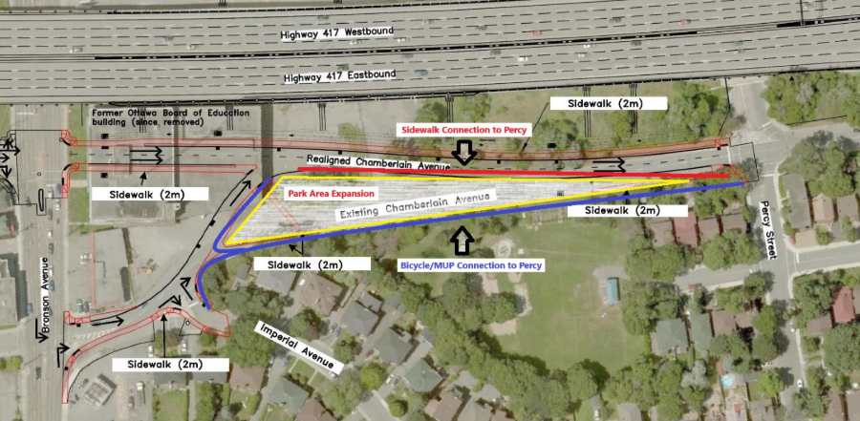

Brown’s Inlet
- Four waste barrels have been added to Brown’s Inlet to help deal with dog waste. This is in addition to the three permanent receptacles.
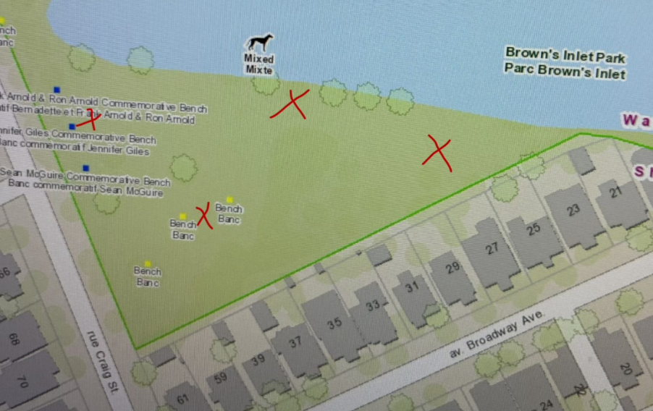

- Additionally, over the past few months, Forestry has also been reviewing potential tree protection measures for Brown's Inlet. They have now drafted several options and met with Parks Maintenance to review them and make sure they’re operationally feasible.
- Ariela and I will meet with them this week to discuss the options. Following the meeting, we will communicate back and share the proposed next steps.

Central Park stairs repair
- The concrete entrance staircase to Central Park from Allan Place will be repaired starting tomorrow (June 24, 2026). This was identified back in 2024 as an item in need of restoration. The work will take ~3 days to complete, weather dependent. The stairs will not be accessible for use while the work is being done. 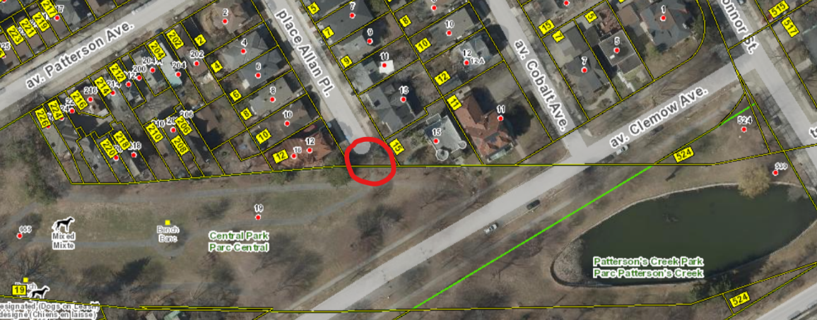
Lionel Britton Park soil remediation
- Site work is still ongoing for Lionel Britton Park.
- There have been a couple of delays with the playground installations but staff are still hoping to see the work completed around the end of July.
- Staff also want to make sure the new grass is well-established and healthy before the park is re-opened.
CILP installations and Exploration Gardens
- Ariela remains in touch with staff to push ahead with the new CILP installations across the ward.
- She also recently followed up with staff to push ahead the revitalization of Exploration Gardens. Parks staff are exceptionally busy this time of year, but we do not want to see this important work falling by the wayside.

Clemow noise
- Following the installation of a Variable Frequency Drive (VFD) at The Clemow in April, BLRS conducted testing from a few locations in late May with the system operating at 100% capacity during the daytime and at night.
- Here are the results they shared: During the daytime reading (4:20pm), readings were taken with the unit on for 20 minutes and again with the unit turned off for 20 minutes.
- Three officers were onsite at three different locations (known to problematic), and no violations were recorded. Ambient noise was quite high with traffic, wind, etc. so further readings were taken later on at night to get a better idea of the general noise.
- Between 10:45pm and 11:30pm, more general readings were taken. Traffic from the 417 was audible but there was no wind. At the three locations, all readings (source noise and ambient noise combined) did not result in a violation being recorded.
- The only hum that could be heard was directly on Clemow and it was faint and generally drowned out by neighbouring residential AC units.
- The locations where readings were conducted are as follows:
  - Percy and Renfrew
  - Percy and Clemow
  - Second and Chrysler
- The feedback we have heard from the community has been mixed; some residents in closer proximity have shared that the noise levels remain roughly the same as last summer, while others feel that the noise is diminished or is not reaching quite as far.
- Higher temperatures will put this to the test. Our office is hopeful that these changes to the HVAC system will provide relief from what was experienced last summer.
- We will continue to monitor this and want to hear your feedback as warmer temperatures come.
- There remain steps that KTS needs to undertake as part of the Planning process that require them to demonstrate compliance with the province's environmental noise guidelines by way of a Stationary Noise Assessment before this matter is closed.

Construction / roads
- Re-paving on Bronson is expected to be done this week.
- There had also been an issue at the intersection of Pretoria and Metcalfe, which we discussed last meeting. For the first week or so, the one block of Metcalfe going south from Pretoria was made into two-way traffic while work was done in the intersection. Metcalfe has now gone back to being one-way. Unfortunately, we still saw a lot of people turning left to go the wrong way on Metcalfe. After we discussed this with you and with the project manager, construction crews set up a barrier using cones and construction tape, effectively closing off any possible left turn there. Since then, we haven't heard any complaints.

Bank and Chamberlain
- The staff report on the land pertaining to the Bank and Chamberlain project with CCOC passed at both committee and Council to approve the transfers of lands.
- As I mentioned last meeting, assuming no delays, we expect that design, zoning, and planning will take about a year.
- Construction is forecast to begin in the second half of 2027.

Youth-free transit
- As a result of a motion Shawn passed last year, Ottawa will now have free transit for youth 18 and under starting July 1st.
- The result is that youth can ride free all summer long starting July 1st. From September to June, youth will ride free all day on weekends and holidays, and after 5pm on weekdays.
- We’re very proud of this work and excited to see it come to life next week!

GCA BUDEGET ESTIMATES 2026-27

 |  | May 1,2026 - April 30,2027
Glebe Community Association |  | Proposed
 |  | BUDGET
COMMITTEE EXPENSES
Environment |  | 200.00
Transportation |  | 200.00
Heritage |  | 200.00
Parks |  | 200.00
Governance |  | 200.00
Health |  | 200.00
Communication |  | 200.00
Membership Drive |  | 1,000.00
OPERATING EXPENSES
Admin |  | 1,000.00
AGM |  | 800.00
Association Memberships |  | 400.00
Insurance |  | 2,300.00
Website/Media |  | 1,600.00
DISCRETIONARY EXPENSES
Great Glebe |  | 1,000.00
Garden Angels |  | 100.00
Municipal Debates |  | 3,000.00
Donations |  | 100.00
TOTAL EXPENSES |  | $ 12,700.00

PROJECTED MEMBERSHIP REVENUE: $ 12,000.00
PROJECTED SURPLUS (DEFICIT): $ (700.00)
BANK BALANCE @ MAY 1, 2026: $ 35,479.30

